**Question 1:-**



**Solution for Question 1:-**

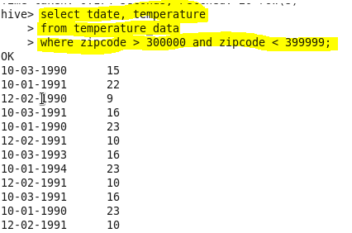

**Question 2:-**



**Solution of Question2:-**

We have created the view named **temperature_data_view** and type casted the string to date.

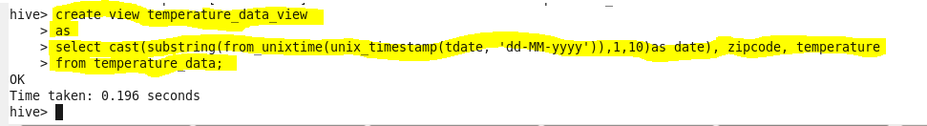

Now we have described **temperature_data_view.** In this, you can see typecasted type as **date**.

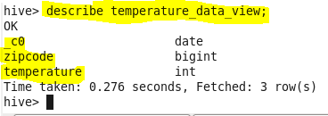

We are going to display the content of the view **temperature_data_view**



Content of **temperature_data_view**

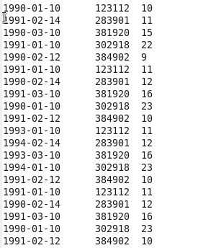

Now we are selecting only year using **YEAR()**

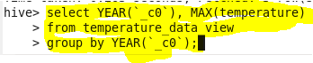

The below screenshot that contains output that displays maximum temperature for ever year.

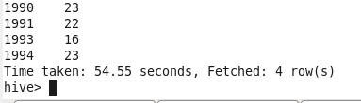

**Question 3:-**



**Solution of Question 3:-**

We have created table named **res_dup.** In that, we have inserted year, count of entries for each year and maximum temperature for each year.

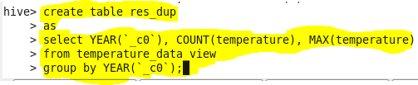

In the below output of res_dup, 1st column represents year, 2nd column represents count of entries for each year, 3rd column represents maximum temperature for each year.

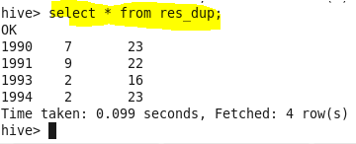

We have described table named res_dup.

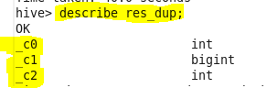

**OUTPUT:-**

Finally we have displayed the maximum temperature for the years that has atleast two entries using the condition (**‘_c1’>=2)** because _c1 represents count of entries for each year.

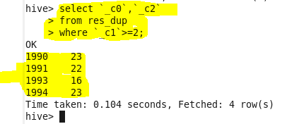

**Question 4:-**



**Explanation:-**

We have created a view named temperature_data_vw.

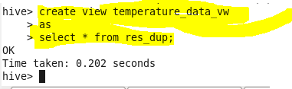

**Output:-**

